

BIBLIOTEKA INFORMUOJA

2025 m. kovo 24 d. Nr. 12 (709)

NAUJIENOS

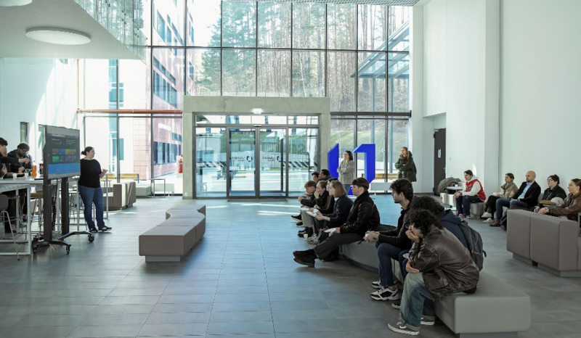VILNIUS TECH studentai ir dėstytojai dalyvavo  JoVE galimybių pristatyme | 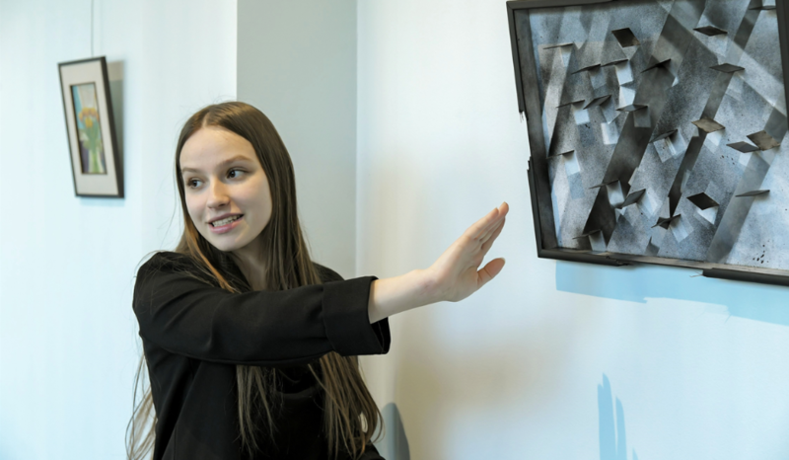  Galerijoje A pristatyta VILNIUS TECH Architektūros fakulteto studentės A. Petkevičiūtės paroda
  VILNIUS TECH SKAITO laisvalaikis: minint Žemės dieną – leidiniai aplinkosaugos temomis | 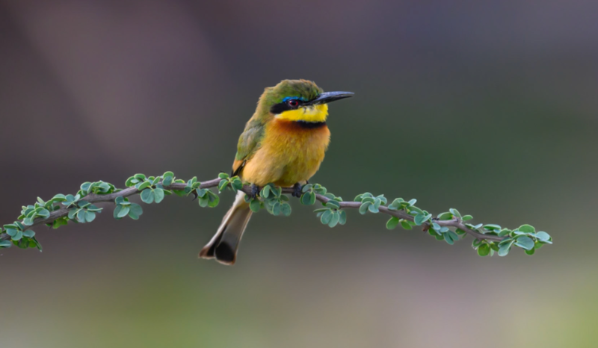  Agnės Vaitkevičiūtės fotografijų paroda  „Spalvingoji Tanzanijos gamta“

Daugiau bibliotekos naujienų
https://biblioteka.vilniustech.lt


DARBUOTOJŲ PUBLIKACIJOS ĮTRAUKTOS Į
WEB OF SCIENCE DUOMENŲ BAZĘ
2025.03.17 – 2025.03.23

Moksliniai straipsniai

Al-Refaie, A., & Lepkova, N. (2025). A fuzzy LARG index for assessing the lean, agile, resilience, and green paradigms in industrial companies. Sustainability, 17(5). https://doi.org/10.3390/su17051863
Žurnalo pozicija pagal kategorijas: ENVIRONMENTAL SCIENCES – Q2; ENVIRONMENTAL STUDIES – Q2; GREEN & SUSTAINABLE SCIENCE & TECHNOLOGY – Q3

Barauskaite-Sarkiniene, N., Novickij, V., Satkauskas, S., & Ruzgys, P. (2025). Investigation of the bystander effect on cell viability after application of combined electroporation-based methods. International Journal of Molecular Sciences, 26(5). https://doi.org/10.3390/ijms26052297
Žurnalo pozicija pagal kategorijas: BIOCHEMISTRY & MOLECULAR BIOLOGY – Q1; CHEMISTRY, MULTIDISCIPLINARY – Q2

Ciupaila, R., Sapagovas, M., Pupalaige, K., & Salteniene, G. K. (2025). On error estimation and convergence of the difference scheme for a nonlinear elliptic equation with an integral boundary condition. Mathematics, 13(5). https://doi.org/10.3390/math13050873
Žurnalo pozicija pagal kategorijas: MATHEMATICS – Q1

Ciziuniene, K., Draugelyte, G., Sokolovskij, E., & Matijosius, J. (2025). Improving small parcel delivery efficiency and sustainability: A study of Lithuanian private delivery company. Sustainability, 17(5). https://doi.org/10.3390/su17051838
Žurnalo pozicija pagal kategorijas: ENVIRONMENTAL SCIENCES – Q2; ENVIRONMENTAL STUDIES – Q2; GREEN & SUSTAINABLE SCIENCE & TECHNOLOGY – Q3

Dirzyte, A. (2025). Large Language Models and the enhancement of human cognition: Some theoretical insights. Filosofija-Sociologija, 36(1), 14–22. https://doi.org/10.6001/fil-soc.2025.36.1.2

Edee, K., Rafailov, E., Vinkovic Vrcek, I., Milenkovic, A. M., & Gric, T. (2025). Statistically correlated disordered freeform random metasurfaces: generation and electromagnetic numerical simulation. Optics Express, 33(5), 11280–11300. https://doi.org/10.1364/OE.550152
Žurnalo pozicija pagal kategorijas: OPTICS – Q2

Goranin, N., Ceponis, D., & Cenys, A. (2025). A systematic literature review of current research trends in operational and related technology threats, threat detection, and security insurance. Applied Sciences-Basel, 15(5). https://doi.org/10.3390/app15052316
Žurnalo pozicija pagal kategorijas: ENGINEERING, MULTIDISCIPLINARY – Q1; CHEMISTRY, MULTIDISCIPLINARY – Q2; PHYSICS, APPLIED – Q2; MATERIALS SCIENCE, MULTIDISCIPLINARY – Q3

Gorzelanczyk, P., & Sokolovskij, E. (2025). Using neural networks to forecast the amount of traffic accidents in Poland and Lithuania. Sustainability, 17(5). https://doi.org/10.3390/su17051846
Žurnalo pozicija pagal kategorijas: ENVIRONMENTAL SCIENCES – Q2; ENVIRONMENTAL STUDIES – Q2; GREEN & SUSTAINABLE SCIENCE & TECHNOLOGY – Q3

Ivaskiene, T., Kaspute, G., Bareikiene, E., & Prentice, U. (2025). Platelet-rich plasma and electrochemical biosensors: A novel approach to ovarian function evaluation and diagnostics. International Journal of Molecular Sciences, 26(5). https://doi.org/10.3390/ijms26052317
Žurnalo pozicija pagal kategorijas: BIOCHEMISTRY & MOLECULAR BIOLOGY – Q1; CHEMISTRY, MULTIDISCIPLINARY – Q2

Jakutis, V. (2025). Urban community in the postmodern urban context. Filosofija-Sociologija, 36(1), 68–75. https://doi.org/10.6001/fil-soc.2025.36.1.8

Kaziliunaite, A. (2025). Living in `interesting times’ as the imperative of asking unimagined questions. Filosofija-Sociologija, 36(1), 1–4.

Koval, V., Shmygol, N., Tamosiuniene, R., Kryshtal, H., Nesenenko, P., & Mikhno, I. (2024). Analysis of factors affecting sustainable consumption and its impact on responsible business management. Transformations in Business & Economics, 23(3A).
Žurnalo pozicija pagal kategorijas: ECONOMICS – Q2; BUSINESS – Q3

Lapinskaite, I., Stasytyte, V., & Skvarciany, V. (2025). Unveiling how efficiently sustainability transforms into intangible assets of financial institutions. Research in International Business and Finance, 76. https://doi.org/10.1016/j.ribaf.2025.102835
Žurnalo pozicija pagal kategorijas: BUSINESS, FINANCE – Q1

Milinkovic, A., Brkljac, D., Skoric, S., Stevic, Z., Danilevicius, A., & Das, D. K. (2025). Evaluation of potentials for urban planning using the fuzzy FUCOM-IMF SWARA-Fuzzy OPARA model. Buildings, 15(5). https://doi.org/10.3390/buildings15050803
Žurnalo pozicija pagal kategorijas: CONSTRUCTION & BUILDING TECHNOLOGY – Q2; ENGINEERING, CIVIL – Q2

Okunevičiūtė Neverauskiene, L., & Kleponė, D. (2024). Empirical evidence on the startup growth in the Baltic region high tech landscape. Transformations in Business & Economics, 23(3A).
Žurnalo pozicija pagal kategorijas: ECONOMICS – Q2; BUSINESS – Q3

Rostamzadeh, R., Baghirov, F., Abdsharafat, M., Saparauskas, J., & Turskis, Z. (2024). Evaluating barriers of change in sustainable supply chain performance using ISM-MicMac methodology. Transformations in Business & Economics, 23(3A).
Žurnalo pozicija pagal kategorijas: ECONOMICS – Q2; BUSINESS – Q3

Stasiulis, N. (2025). Heideggerian notes on education: Learning and being-in-the-world. Filosofija-Sociologija, 36(1), 42–49. https://doi.org/10.6001/fil-soc.2025.36.1.5

Urbonavicius, J., Cekyte, A., & Tauraite, D. (2025). N⁴-methylcytosine supports the growth of Escherichia coli uracil auxotrophs. International Journal of Molecular Sciences, 26(5). https://doi.org/10.3390/ijms26051812
Žurnalo pozicija pagal kategorijas: BIOCHEMISTRY & MOLECULAR BIOLOGY – Q1; CHEMISTRY, MULTIDISCIPLINARY – Q2

Valatka, V. (2025). The first age of logic in Lithuania: Propositio as such and the necessary propositions. Filosofija-Sociologija, 36(1), 94–100. https://doi.org/10.6001/fil-soc.2025.36.1.11

Wang, Y., Wang, X., Balezentis, T., Chi, Y., & Streimikiene, D. (2025). Disentangling the effects of green finance in reducing CO2 emission from energy systems: Evidence from a novel factor decomposition mechanism. Economic Analysis and Policy, 85, 1721–1738. https://doi.org/10.1016/j.eap.2025.02.022
Žurnalo pozicija pagal kategorijas: ECONOMICS – Q1

Konferencijų pranešimai

Petrulis, B., Macaitis, V., Barzdenas, V., Gražulevičius, G., Wang, S., & Chuang, C. (2024). Wide tuning range X-band LC-VCO designed in 90 nm CMOS technology. In D. Kolosovs (Ed.), 2024 IEEE Workshop on Microwave Theory and Technology in Wireless Communications, MTTW 2024 (pp. 24–28). https://doi.org/10.1109/MTTW64344.2024.10742164

Žurnalų pozicijos pagal kategorijas nurodytos, jei bent vienoje kategorijoje žurnalas patenka į 1 arba 2 kvartilę (Q) pagal JIF rodiklio reikšmes.

DARBUOTOJŲ PUBLIKACIJOS ĮTRAUKTOS
Į SCOPUS DUOMENŲ BAZĘ
2025.03.17 – 2025.03.23

Moksliniai straipsniai

Al-Refaie, A., Daboseh, L., & Lepkova, N. (2025). Assessment of frugal innovation in spare parts of end-of-life vehicles. Jordan Journal of Mechanical and Industrial Engineering, 19(1), 79–90. https://doi.org/10.59038/jjmie/190106

Al-Refaie, A., & Lepkova, N. (2025). A fuzzy LARG index for assessing the lean, agile, resilience, and green paradigms in industrial companies. Sustainability (Switzerland), 17(5). https://doi.org/10.3390/su17051863
Žurnalo pozicija pagal kategorijas:
Social Sciences: Geography, Planning and Development – Q1
Computer Science: Computer Science (miscellaneous) – Q1
Environmental Science: Environmental Science (miscellaneous) – Q1
Environmental Science: Management, Monitoring, Policy and Law – Q1
Computer Science: Computer Networks and Communications – Q1
Energy: Energy Engineering and Power Technology – Q2
Computer Science: Hardware and Architecture – Q2
Energy: Renewable Energy, Sustainability and the Environment – Q2

Barauskaitė-Šarkinienė, N., Novickij, V., Šatkauskas, S., & Ruzgys, P. (2025). Investigation of the bystander effect on cell viability after application of combined electroporation-based methods. International Journal of Molecular Sciences, 26(5). https://doi.org/10.3390/ijms26052297
Žurnalo pozicija pagal kategorijas:
Chemistry: Inorganic Chemistry – Q1
Chemistry: Organic Chemistry – Q1
Chemistry: Spectroscopy – Q1
Chemistry: Physical and Theoretical Chemistry – Q1
Computer Science: Computer Science Applications – Q1
Biochemistry, Genetics and Molecular Biology: Molecular Biology – Q2
Chemical Engineering: Catalysis – Q2

Bradulienė, J., Vaišis, V., & Vaiškūnaite, R. (2024). The seasonal change of water quality parameters and ecological condition of some surface water bodies in the Nemunas river basin. Journal of Environmental Engineering and Landscape Management, 32(4), 241–254. https://doi.org/10.3846/jeelm.2024.22360

Brzozowski, A., Szewczyk, R., Gazda, P., & Nowicki, M. (2024). Functional parameters of sensors for the extended cross-float method. Metrology and Measurement Systems, 31(4), 863–873. https://doi.org/10.24425/mms.2024.152056

Čiupaila, R., Sapagovas, M., Pupalaigė, K., & Šaltenienė, G. K. (2025). On error estimation and convergence of the difference scheme for a nonlinear elliptic equation with an integral boundary condition. Mathematics, 13(5). https://doi.org/10.3390/math13050873
Žurnalo pozicija pagal kategorijas:
Mathematics: General Mathematics – Q1
Engineering: Engineering (miscellaneous) – Q2
Computer Science: Computer Science (miscellaneous) – Q2

Čižiūnienė, K., Draugelytė, G., Sokolovskij, E., & Matijošius, J. (2025). Improving small parcel delivery efficiency and sustainability: A study of Lithuanian private delivery company. Sustainability (Switzerland), 17(5). https://doi.org/10.3390/su17051838
Žurnalo pozicija pagal kategorijas:
Social Sciences: Geography, Planning and Development – Q1
Computer Science: Computer Science (miscellaneous) – Q1
Environmental Science: Environmental Science (miscellaneous) – Q1
Environmental Science: Management, Monitoring, Policy and Law – Q1
Computer Science: Computer Networks and Communications – Q1
Energy: Energy Engineering and Power Technology – Q2
Computer Science: Hardware and Architecture – Q2
Energy: Renewable Energy, Sustainability and the Environment – Q2

Diržytė, A. (2025). Large Language Models and the enhancement of human cognition: Some theoretical insights. Filosofija, Sociologija, 36(1), 14-22. https://doi.org/10.6001/fil-soc.2025.36.1.2
Žurnalo pozicija pagal kategorijas:
Arts and Humanities: Philosophy – Q2
Social Sciences: Sociology and Political Science – Q3

Duraisamy, B., Palanichamy, S., Varuvel, E. G., Stanley, M. J., Sonthalia, A., Mubarak, M., Subramanian, T., John, J. G., Chinnathambi, A., & Pugazhendhi, A. (2025). Enhancing performance and reducing emissions with renewable fuels: Prosopis Juliflora methyl ester–alcohol blends with hydrogen in a compression ignition engine. International Journal of Hydrogen Energy. https://doi.org/10.1016/j.ijhydene.2025.02.153
Žurnalo pozicija pagal kategorijas:
Physics and Astronomy: Condensed Matter Physics – Q1
Energy: Energy Engineering and Power Technology – Q1
Energy: Fuel Technology – Q1
Energy: Renewable Energy, Sustainability and the Environment – Q1

Edee, K., Rafailov, E., Vinković Vrček, I., Milenkovic, A. M., & Gric, T. (2025). Statistically correlated disordered freeform random metasurfaces: generation and electromagnetic numerical simulation. Optics Express, 33(5), 11280–11300. https://doi.org/10.1364/OE.550152
Žurnalo pozicija pagal kategorijas:
Physics and Astronomy: Atomic and Molecular Physics, and Optics – Q1

Estiri, M., Dahooie, J. H., Qorbani, A. R., & Meidute-Kavaliauskiene, I. (2025). Why do talented people leave? Assessing talent turnover risks using a hybrid approach. Strategic Change, 34(2), 315–335. https://doi.org/10.1002/jsc.2621
Žurnalo pozicija pagal kategorijas:
Economics, Econometrics and Finance: Finance – Q1
Business, Management and Accounting: General Business, Management and Accounting – Q1

Goranin, N., Čeponis, D., & Čenys, A. (2025). A systematic literature review of current research trends in operational and related technology threats, threat detection, and security insurance. Applied Sciences (Switzerland), 15(5). https://doi.org/10.3390/app15052316
Žurnalo pozicija pagal kategorijas:
Engineering: General Engineering – Q1
Physics and Astronomy: Instrumentation – Q2
Chemical Engineering: Fluid Flow and Transfer Processes – Q2
Computer Science: Computer Science Applications – Q2
Materials Science: General Materials Science – Q2
Chemical Engineering: Process Chemistry and Technology – Q3

Gorzelańczyk, P., & Sokolovskij, E. (2025). Using neural networks to forecast the amount of traffic accidents in Poland and Lithuania. Sustainability (Switzerland), 17(5). https://doi.org/10.3390/su17051846
Žurnalo pozicija pagal kategorijas:
Social Sciences: Geography, Planning and Development – Q1
Computer Science: Computer Science (miscellaneous) – Q1
Environmental Science: Environmental Science (miscellaneous) – Q1
Environmental Science: Management, Monitoring, Policy and Law – Q1
Computer Science: Computer Networks and Communications – Q1
Energy: Energy Engineering and Power Technology – Q2
Computer Science: Hardware and Architecture – Q2
Energy: Renewable Energy, Sustainability and the Environment – Q2

Holmen, R. B., Carvelli, G., Razminienė, K., & Tvaronavičienė, M. (2025). Macroeconomic influences on recycling in Europe: An econometric investigation. Circular Economy and Sustainability, 5(1), 573–602. https://doi.org/10.1007/s43615-024-00418-x
Žurnalo pozicija pagal kategorijas:
Environmental Science: General Environmental Science – Q1
Energy: Renewable Energy, Sustainability and the Environment – Q2

Ivaskiene, T., Kaspute, G., Bareikiene, E., & Prentice, U. (2025). Platelet-rich plasma and electrochemical biosensors: A novel approach to ovarian function evaluation and diagnostics. International Journal of Molecular Sciences, 26(5). https://doi.org/10.3390/ijms26052317
Žurnalo pozicija pagal kategorijas:
Chemistry: Inorganic Chemistry – Q1
Chemistry: Organic Chemistry – Q1
Chemistry: Spectroscopy – Q1
Chemistry: Physical and Theoretical Chemistry – Q1
Computer Science: Computer Science Applications – Q1
Biochemistry, Genetics and Molecular Biology: Molecular Biology – Q2
Chemical Engineering: Catalysis – Q2

Jakutis, V. (2025). Urban community in the postmodern urban context. Filosofija, Sociologija, 36(1), 68–75. https://doi.org/10.6001/fil-soc.2025.36.1.8
Žurnalo pozicija pagal kategorijas:
Arts and Humanities: Philosophy – Q2
Social Sciences: Sociology and Political Science – Q3

Larsson, G., Mažeikienė, A., & Smaliukienė, R. (2025). Psychological prediction of stress-related hair steroid hormone levels in young men: a person-centered approach. Nordic Psychology, 77(1), 26–38. https://doi.org/10.1080/19012276.2023.2247571

Masėnas, J., & Valivonis, J. (2025). Evaluation of connectors’ influence on the interface behaviour between concrete layers. Materials and Structures/Materiaux et Constructions, 58(1). https://doi.org/10.1617/s11527-024-02553-1
Žurnalo pozicija pagal kategorijas:
Engineering: Building and Construction – Q1
Engineering: Civil and Structural Engineering – Q1
Engineering: Mechanics of Materials – Q1
Materials Science: General Materials Science – Q2

Milinković, A., Brkljač, D., Škorić, S., Stević, Ž., Danilevičius, A., & Das, D. K. (2025). Evaluation of potentials for urban planning using the fuzzy FUCOM-IMF SWARA-Fuzzy OPARA model. Buildings, 15(5). https://doi.org/10.3390/buildings15050803
Žurnalo pozicija pagal kategorijas:
Engineering: Architecture – Q1
Engineering: Building and Construction – Q1
Engineering: Civil and Structural Engineering – Q2

Okunevičiūtė Neverauskienė, L., Žalimienė, L., & Junevičienė, J. (2024). “Yes or no? What do Lithuanian unemployed young people think about employment in elderly care sector?” Calitatea Vietii, 35(4), 245–263. https://doi.org/10.46841/RCV.2024.04.03

Petrović, N., Jovanović, V., Marković, S., Marinković, D., & Nikolić, B. (2025). Multi-criteria decision-making approach for choising e-Bus for urban public transport in the city of Niš. Acta Technica Jaurinensis, 18(1), 1–8. https://doi.org/10.14513/actatechjaur.00758

Poppi, F. I. M. (2025). Limen transitus: negotiating identities of criminality and solidarity among border-crossing facilitators. Identities. https://doi.org/10.1080/1070289X.2025.2476324
Žurnalo pozicija pagal kategorijas:
Social Sciences: Cultural Studies – Q1
Social Sciences: Anthropology – Q1
Arts and Humanities: Arts and Humanities (miscellaneous) – Q1

Rimkus, A., Kozłowski, E., Vipartas, T., Pukalskas, S., Wiśniowski, P., & Matijošius, J. (2025). Emission characteristics of hydrogen-enriched gasoline under dynamic driving conditions. Energies, 18(5). https://doi.org/10.3390/en18051190
Žurnalo pozicija pagal kategorijas:
Mathematics: Control and Optimization – Q1
Engineering: Engineering (miscellaneous) – Q1
Engineering: Electrical and Electronic Engineering – Q2
Energy: Energy Engineering and Power Technology – Q2
Energy: Fuel Technology – Q2
Energy: Energy (miscellaneous) – Q2
Energy: Renewable Energy, Sustainability and the Environment – Q2

Sivilevičius, H., & Žuraulis, V. (2025). Modeling the impact of interaction factors for transport system elements on quality of life using multi-criteria decision-making and applied statistical methods. Sustainability (Switzerland), 17(5). https://doi.org/10.3390/su17051784
Žurnalo pozicija pagal kategorijas:
Social Sciences: Geography, Planning and Development – Q1
Computer Science: Computer Science (miscellaneous) – Q1
Environmental Science: Environmental Science (miscellaneous) – Q1
Environmental Science: Management, Monitoring, Policy and Law – Q1
Computer Science: Computer Networks and Communications – Q1
Energy: Energy Engineering and Power Technology – Q2
Computer Science: Hardware and Architecture – Q2
Energy: Renewable Energy, Sustainability and the Environment – Q2

Urbonavičius, J., Čekytė, A., & Tauraitė, D. (2025). N⁴-methylcytosine supports the growth of Escherichia coli uracil auxotrophs. International Journal of Molecular Sciences, 26(5). https://doi.org/10.3390/ijms26051812
Žurnalo pozicija pagal kategorijas:
Chemistry: Inorganic Chemistry – Q1
Chemistry: Organic Chemistry – Q1
Chemistry: Spectroscopy – Q1
Chemistry: Physical and Theoretical Chemistry – Q1
Computer Science: Computer Science Applications – Q1
Biochemistry, Genetics and Molecular Biology: Molecular Biology – Q2
Chemical Engineering: Catalysis – Q2

Ušinskis, V., Nowicki, M., Dzedzickis, A., & Bučinskas, V. (2025). Sensor-fusion based navigation for autonomous mobile robot. Sensors (Basel, Switzerland), 25(4). https://doi.org/10.3390/s25041248
Žurnalo pozicija pagal kategorijas:
Physics and Astronomy: Instrumentation – Q1
Engineering: Electrical and Electronic Engineering – Q1
Physics and Astronomy: Atomic and Molecular Physics, and Optics – Q1
Chemistry: Analytical Chemistry – Q1
Computer Science: Information Systems – Q1
Biochemistry, Genetics and Molecular Biology: Biochemistry – Q2

Valatka, V. (2025). The first age of logic in Lithuania: Propositio as such and the necessary propositions. Filosofija, Sociologija, 36(1), 94–100. https://doi.org/10.6001/fil-soc.2025.36.1.11
Žurnalo pozicija pagal kategorijas:
Arts and Humanities: Philosophy – Q2
Social Sciences: Sociology and Political Science – Q3

Konferencijų pranešimai

Šabanovič, A., Matijošius, J., Kilikevičius, A., & Chlebnikovas, A. (2025). Assessment of particle dynamics in electric air filters: The role of ionic wind in air quality improvement. Lecture Notes in Networks and Systems, 1258 LNNS, 391–400. https://doi.org/10.1007/978-3-031-81799-1_36

Yeung, A. T., & Ng, P. L. (2025). Real-time management of public fill in Hong Kong using information and communications technology. Geo-EnvironMeet 2025: Geoenvironmental Contamination and Waste Containment, GSP 359, 246–255. https://doi.org/10.1061/9780784485699.027
Žurnalo pozicija pagal kategorijas:
Engineering: Architecture – Q2
Engineering: Building and Construction – Q4
Earth and Planetary Sciences: Geotechnical Engineering and Engineering Geology – Q4
Engineering: Civil and Structural Engineering – Q4

Zolfaghari, F., Kale-Halasz, G., Alharasees, O., & Kilikevicius, A. (2025). Application of deep learning models for predicting health alerts in pilots. Lecture Notes in Networks and Systems, 1258 LNNS, 445–457. https://doi.org/10.1007/978-3-031-81799-1_41

Knygų skyriai

Bieliatynska, A., Čižiūnienė, K., Klymenko, I., & Matijošius, J. (2024). Supply chain challenges in wartime: LLC “Raben Ukraine” key study. In Studies in Systems, Decision and Control (Vol. 563, pp. 433–483). https://doi.org/10.1007/978-3-031-69487-5_8
Žurnalo pozicija pagal kategorijas:
Social Sciences: Social Sciences (miscellaneous) – Q2
Economics, Econometrics and Finance: Economics, Econometrics and Finance (miscellaneous) – Q2
Engineering: Automotive Engineering – Q3
Decision Sciences: Decision Sciences (miscellaneous) – Q3
Mathematics: Control and Optimization – Q3
Engineering: Control and Systems Engineering – Q3
Computer Science: Computer Science (miscellaneous) – Q3

Žurnalų pozicijos pagal kategorijas nurodytos, jei bent vienoje kategorijoje žurnalas patenka į 1 arba 2 kvartilę (Q). Scopus DB žurnalai į kvartiles skirstomi pagal CiteScore rodiklio reikšmes.

Primename, kad Web of Science ir Scopus DB indeksuojamas publikacijas eLABa PDB užregistruosite greičiau ir tiksliau, jei pasinaudosite įrašų importo iš Web of Science arba Scopus DB į eLABa PDB funkcija.

VILNIUS TECH bibliotekos tinklapyje, Mokslinės komunikacijos skiltyje, rasite naudingos informacijos apie:
- Žurnalo pasirinkimą publikavimui: žurnalų paiešką, jų kokybės ir patikimumo vertinimą
- Atvirąją prieigą: atvirosios prieigos principus, publikavimo modelius, autorių teises ir licencijas, atviros prieigos šaltinių paiešką, APC mokesčius ir VILNIUS TECH autoriams prieinamas APC nuolaidas
- Mokslinių tyrimų rezultatų matomumo didinimą ir jų vertinimą
- Web of Science (Clarivate Analytics) duomenų bazę: jos turinį, naudojimą ir papildomus VILNIUS TECH bendruomenei prieinamus analizės įrankius
- Scopus (Elsevier) duomenų bazę: jos turinį ir naudojimą
- Publikacijų registravimą ir ataskaitų generavimą eLABa PDB sistemoje

Informaciją parengė:

Orinta Sajetienė
tel.: (0 5) 251 2254, vietinis 9254
el.p.orinta.sajetiene@vilniustech.lt

Konradas Galvydis
tel.: (0 5) 274 4903, vietinis 9903
el. p: konradas.galvydis@vilniustech.lt

